Category 1 - Simple Questions

1.Using the patient table and the calc_deaths_cleaned table, for each opo and referral_year, calculate the total number of referrals (count of patient_id) and display it alongside the calc_deaths from calc_deaths_cleaned (matched by opo and year).Then determine which opo had the largest difference between total referrals and calc_deaths for a given year.

Reason

The total number of referrals per referral_year (from the patient table) represents how many potential donors were actually referred to the OPO.
Calculated deaths (calc_deaths in calc_deaths_cleaned) estimate how many potential donors could have been referred based on mortality data.
If actual referrals are close to or higher than calculated deaths, the OPO is effectively capturing most potential donors.
If referrals are much lower than calculated deaths, it indicates missed opportunities.
By comparing these two measures, we obtain a quantitative assessment of OPO performance and identify areas for improvement in the organ donation process.

Optimization Technique
Using Indexes on Join Columns .This query joins two tables using opo and referral_year/year. To make it faster, we create indexes on those columns. An index works like a book index — instead of scanning the whole table, PostgreSQL can quickly find matching rows.

QUERY
SELECT
p.opo,
p.referral_year,
COUNT(p.patient_id) AS total_referrals,
c.calc_deaths,
COUNT(p.patient_id) - c.calc_deaths AS difference
FROM
patient p
JOIN
calc_deaths_cleaned c
ON p.opo = c.opo
AND p.referral_year = c.year
GROUP BY
p.opo,
p.referral_year,
c.calc_deaths
ORDER BY
difference DESC;

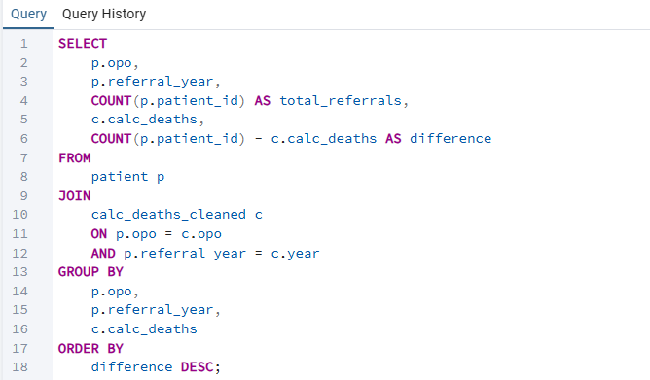

Output
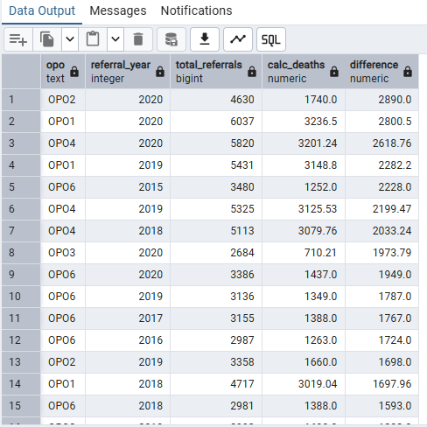

Insight
- total_referrals – Number of patients who were referred to the OPO in that year.These are potential donors, not necessarily transplanted yet.
- calc_deaths – The estimated number of deaths in that OPO in that year (from calc_deaths).
- difference = total_referrals - calc_deaths – This is just the gap between actual referrals and expected deaths.
  - Positive difference → more referrals than expected deaths
  - Negative difference → fewer referrals than expected deaths
Example: OP02 in 2020: total_referrals = 4630, calc_deaths = 1740, difference = 2890
Interpretation: This OPO referred more patients than expected deaths, which might indicate excellent outreach or overcounting, depending on context.

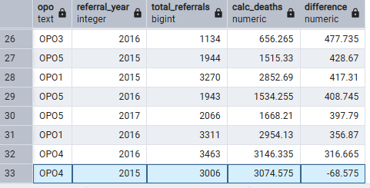

Here in row 33 we have a Negative difference: -68.575 → fewer referrals than expected deaths.
Interpretation: In 2015, OPO4 referred about 69 fewer potential donors than the estimated number of deaths in their area.
It indicates a potential gap in referrals; some patients who could have been referred as potential donors were not referred.
Hence In 2015, OPO4 referred slightly fewer patients than expected based on estimated deaths, which suggests potential missed opportunities for organ donation.

2.Create age categories (<20, 20–39, 40–59, 60+). For each age category, count the number of patients declared brain-dead (brain_death) and the number of those whose organs were transplanted (transplanted). Display the results in descending order by the number of brain-dead patients.

Reason
Brain-dead patients are the main source of organs for transplantation. Analyzing their age distribution and how many were transplanted helps identify the largest donor pools, assess organ utilization efficiency, and optimize referral and procurement processes to improve transplant outcomes.

Optimization Technique

Create Indexes on Join and Filter Columns
This query:
- Joins tables using patient_id
- Filters using d.brain_death = 'true'
- Groups by age category
To make it faster, we create indexes on the columns used for joining and filtering.
Query
SELECT
CASE
WHEN p.age < 20 THEN '<20'
WHEN p.age BETWEEN 20 AND 39 THEN '20-39'
WHEN p.age BETWEEN 40 AND 59 THEN '40-59'
ELSE '60+'
END AS age_group,
COUNT(*) AS brain_dead_count,
SUM(CASE
WHEN a.transplanted = 'true' THEN 1
ELSE 0
END) AS transplanted_count
FROM patient p
JOIN death_info d
ON p.patient_id = d.patient_id
JOIN auth_status a
ON p.patient_id = a.patient_id
WHERE d.brain_death = 'true'
GROUP BY age_group
ORDER BY brain_dead_count DESC;

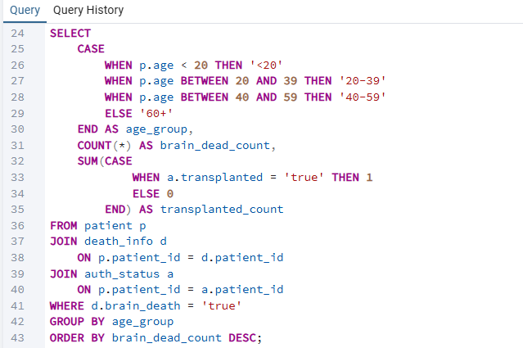

Output
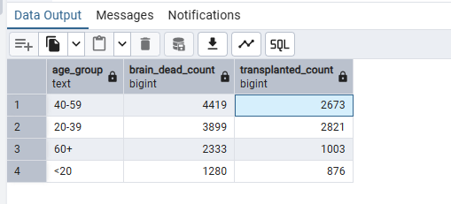

Insight
The 40–59 age group has the highest number of brain-dead patients (4419) and a large number of transplants (2673), indicating it’s the largest potential donor pool. The 20–39 group also shows a high transplant count relative to brain-dead patients, suggesting efficient organ utilization. Younger (<20) and older (60+) groups contribute fewer donors, highlighting where referral and procurement strategies could be optimized.

3.For each ABO_BloodType, calculate the percentage of referrals that were authorized and procured. Return the blood type, total referrals, total authorized, total procured, and the percentages.

Reason
Blood type is critical for organ matching. Analyzing referrals by blood type, along with how many were authorized and procured, helps identify which blood groups have the highest donor potential. It highlights gaps where referrals aren’t converted into actual donations and shows organ procurement efficiency, guiding OPOs to optimize processes and save more lives.

Optimization Technique
Create Indexes on Join Columns
This query joins three tables using patient_id and groups by abo_blood_type.
To make it faster, we create indexes on the columns used for joining.
Query
SELECT
b.abo_blood_type AS abo_bloodtype,
COUNT(*) AS total_referrals,
SUM(CASE WHEN a.authorized = TRUE THEN 1 ELSE 0 END) AS total_authorized,
SUM(CASE WHEN a.procured = TRUE THEN 1 ELSE 0 END) AS total_procured,
ROUND(SUM(CASE WHEN a.authorized = TRUE THEN 1 ELSE 0 END) * 100.0 / COUNT(*), 2) AS percent_authorized,
ROUND(SUM(CASE WHEN a.procured = TRUE THEN 1 ELSE 0 END) * 100.0 / COUNT(*), 2) AS percent_procured
FROM patient p
JOIN blood_tissue b
ON p.patient_id = b.patient_id
JOIN auth_status a
ON p.patient_id = a.patient_id
GROUP BY b.abo_blood_type
ORDER BY total_referrals;
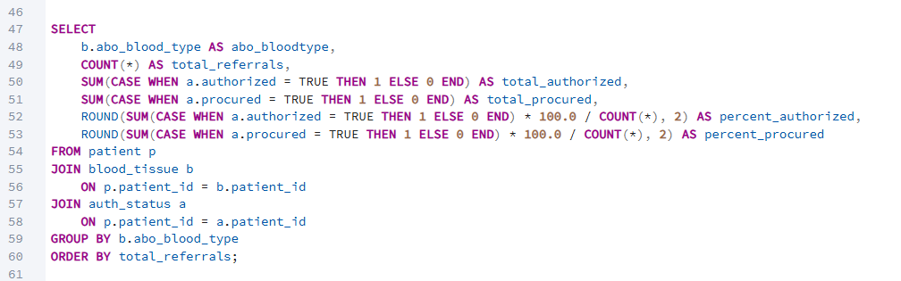
Output
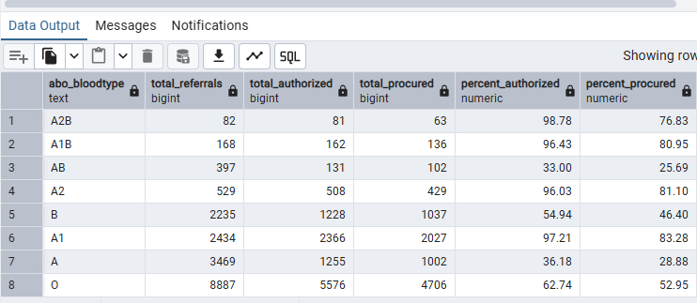
Insight
Blood type is important for organ matching, and the results show big differences between blood groups.
A1, A2, A1B, and A2B have very high authorization and procurement rates. This means most referrals in these groups successfully became organ donations.
O blood type has the highest number of referrals, so it contributes the most donors overall.
B and A blood types have medium conversion rates, so there is room to improve how many referrals become actual donations.
AB blood type has low authorization and procurement rates, which may show process issues.
The UNKNOWN blood type has a very large number of referrals but almost no authorization or procurement. This likely means there is a data problem that needs to be fixed.

4.Calculate the average time (in hours) from time_referred → time_approached → time_procured for each OPO. Which OPO has the fastest average approach-to-procurement time?

Reason
It identifies which OPOs move fastest from referral to procurement, helping detect delays and improve efficiency in a time-critical process. Faster coordination can directly improve organ viability and transplant success, which means this analysis can help save more lives.

Optimization Technique
Create Indexes on Join and Filter Columns
This query:
- Joins patient and auth_status using patient_id
- Filters rows where time columns are NOT NULL
- Groups results by opo
To make it faster, we create indexes on the columns used for joining and grouping.

Query
SELECT
p.opo,
ROUND(AVG(EXTRACT(EPOCH FROM (a.time_approached - a.time_referred)) / 3600), 2)
AS avg_hours_referral_to_approach,
ROUND(AVG(EXTRACT(EPOCH FROM (a.time_procured - a.time_approached)) / 3600), 2)
AS avg_hours_approach_to_procurement
FROM patient p
JOIN auth_status a
ON p.patient_id = a.patient_id
WHERE a.time_referred IS NOT NULL
AND a.time_approached IS NOT NULL
AND a.time_procured IS NOT NULL
GROUP BY p.opo
ORDER BY avg_hours_approach_to_procurement ASC;

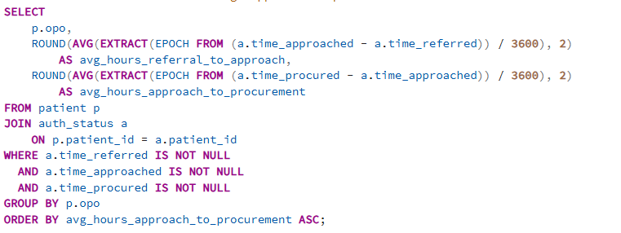

Output
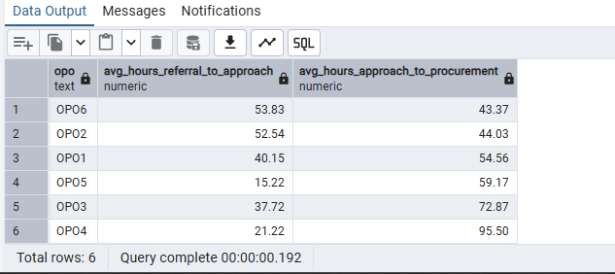
Insight
OPO5 (15.22 hrs) and OPO4 (21.22 hrs) have the fastest approach-to-procurement times, meaning they move quickly once the family is approached.
However, OPO4 (95.50 hrs) and OPO3 (72.87 hrs) take a very long time from referral to approach, showing delays at the early stage.
OPO6 and OPO2 are slower in the approach-to-procurement phase (above 52 hrs), which may affect organ viability.

5.Categorize patients into age groups (Minor, Adult, Senior).

Optimization Techniques
- Uses a CASE expression
Categorizes age groups in a single pass over the data, which is efficient.
- Simple conditions on a column (age)
- Query
SELECT
patient_id,
age,
CASE
WHEN age IS NULL THEN 'Unknown'
WHEN age < 18 THEN 'Minor'
WHEN age BETWEEN 18 AND 64 THEN 'Adult'
ELSE 'Senior'
END AS age_group
FROM patient;
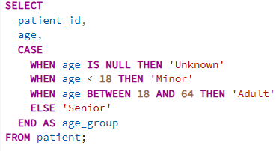
Output
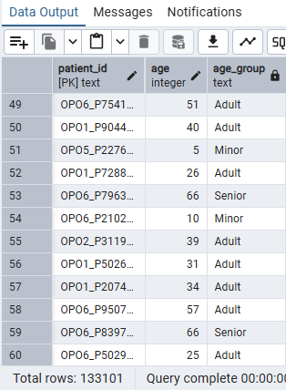

Insight
This query classifies patients into age groups using their age value.
- Patients younger than 18 are labeled Minor
- Patients aged 18–64 are labeled Adult
- Patients aged 65 and above are labeled Senior
- Missing age values are handled separately as Unknown
This helps in analyzing patient distribution across age categories.

6. Count the number of brain death cases year-wise.

Optimization Techniques
- Index on patient_id
Improves join performance between the death_info and patient tables by allowing faster matching of records.
- Early filtering on brain_death = true
Reduces the number of rows processed by selecting only relevant brain-death cases before aggregation.
- Filtering out NULL procured_year values
Avoids unnecessary grouping and improves accuracy of year-wise counts.
- Using COUNT(DISTINCT patient_id)
Prevents duplicate counting of the same patient when joining tables.
- Grouping by procured_year only
Keeps aggregation minimal and efficient.

Query
SELECT p.procured_year,
COUNT(DISTINCT d.patient_id) AS brain_death_count
FROM death_info d
JOIN patient p
ON d.patient_id = p.patient_id
WHERE d.brain_death = true
AND p.procured_year IS NOT NULL
GROUP BY p.procured_year
ORDER BY p.procured_year;
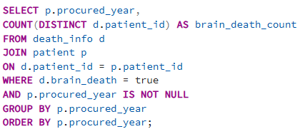
Output
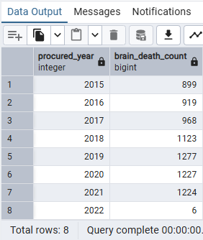
Insight
Helps analyze the year-wise trend of brain death cases
- Shows how brain death counts change over time
- Avoids double counting by using distinct patient IDs
- Supports planning and decision-making for critical care and organ donation
Makes it easier to compare years and identify increases or decreases in cases

7. Find the race which has the highest transplant rate?

Optimization Techniques
- Index on patient_id
Improved join performance between the patient and auth_status tables.
- Filtering out NULL race values early
Reduced unnecessary grouping and improved result accuracy.
- Using SUM(CASE )
Allowed transplant counts and total counts to be calculated in a single scan.
- Grouping only by required column (race)
Minimized aggregation overhead and improved performance

Query
SELECT p.race,
ROUND(SUM(CASE WHEN a.transplanted = true THEN 1 ELSE 0 END) * 100.0/ COUNT(*),2)
AS transplant_rate_percentage
FROM patient p
JOIN auth_status a
ON p.patient_id = a.patient_id
WHERE p.race IS NOT NULL
GROUP BY p.race
ORDER BY transplant_rate_percentage DESC
LIMIT 1;

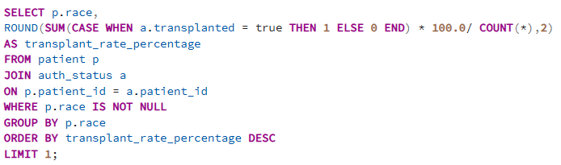
Output
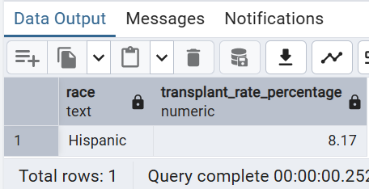
Insight
This analysis helps compare transplant success across different racial groups. It shows which race has a higher transplant rate and helps highlight possible differences in referral, approval, or treatment outcomes. These insights can be useful for reviewing processes and ensuring more balanced healthcare delivery.

8. Find Year-wise number of brain-dead donors who had at least one organ transplanted.

Optimization Techniques Used :
- Indexes on patient_id
Improved performance of joins between death_info, patient, and organ_outcome tables.
- Early filtering on brain_death = true
Reduced the number of rows processed before applying joins and aggregations.
- Use of COUNT(DISTINCT patient_id)
Avoided duplicate donor counts when multiple organs were transplanted for the same patient.
- Partial indexing on transplanted organ outcomes
Limited scans to only rows where at least one organ was transplanted, improving query efficiency.
- Grouping by year (procured_year)
Enabled faster year-wise aggregation and trend analysis.

Query
SELECT p.procured_year,
COUNT(DISTINCT di.patient_id) AS brain_death_transplanted_cases
FROM death_info di
JOIN patient p
ON p.patient_id = di.patient_id
JOIN organ_outcome oo
ON oo.patient_id = di.patient_id
WHERE di.brain_death = true
AND p.procured_year IS NOT NULL
AND (
oo.outcome_heart = 'Transplanted' OR
oo.outcome_liver = 'Transplanted' OR
oo.outcome_kidney_left = 'Transplanted' OR
oo.outcome_kidney_right = 'Transplanted' OR
oo.outcome_lung_left = 'Transplanted' OR
oo.outcome_lung_right = 'Transplanted' OR
oo.outcome_pancreas = 'Transplanted' OR
oo.outcome_intestine = 'Transplanted'
)
GROUP BY p.procured_year
ORDER BY p.procured_year;

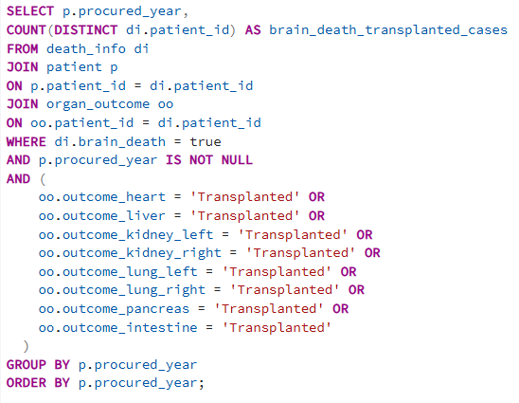

Output
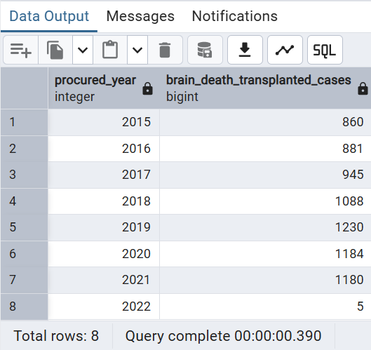

Insight
This query was optimized to efficiently analyze large healthcare datasets by identifying brain-dead donors who successfully donated at least one organ and summarizing the results by year. Since the query involves multiple table joins and several filter conditions, optimization ensures faster execution and accurate year-wise reporting.

9.Count transplanted organs per year.
Reason :
To find how many organs are transplanted in all the OPOs every year.

Optimization Techniques:

1.SUM(CASE WHEN … THEN 1 ELSE 0 END), which is an efficient way to do conditional counting in SQL (better than multiple subqueries).
2.INNER JOINs, which avoid unnecessary rows compared to subqueries.
3. applied the WHERE a.transplanted = 'Yes' filter before grouping, which reduces rows early and improves aggregation performance.
4.grouped only by referral_year, keeping the grouping minimal and efficient.

Query

SELECT
p.referral_year,
SUM(CASE WHEN o.outcome_heart = 'Transplanted' THEN 1 ELSE 0 END)
AS transplanted_hearts_count,
SUM(CASE WHEN o.outcome_liver = 'Transplanted' THEN 1 ELSE 0 END)
AS transplanted_livers_count,
SUM(CASE WHEN o.outcome_kidney_left = 'Transplanted' THEN 1 ELSE 0 END) +
SUM(CASE WHEN o.outcome_kidney_right = 'Transplanted' THEN 1 ELSE 0 END)
AS transplanted_kidneys_count,
SUM(CASE WHEN o.outcome_lung_left = 'Transplanted' THEN 1 ELSE 0 END) +
SUM(CASE WHEN o.outcome_lung_right = 'Transplanted' THEN 1 ELSE 0 END)
AS transplanted_lungs_count,
SUM(CASE WHEN o.outcome_intestine = 'Transplanted' THEN 1 ELSE 0 END)
AS transplanted_intestine_count,
SUM(CASE WHEN o.outcome_pancreas = 'Transplanted' THEN 1 ELSE 0 END)
AS transplanted_pancreas_count
FROM patient p
JOIN organ_outcome o
ON p.patient_id = o.patient_id
JOIN auth_status a
ON p.patient_id = a.patient_id
WHERE a.transplanted = 'Yes'
GROUP BY p.referral_year
ORDER BY p.referral_year;

Output
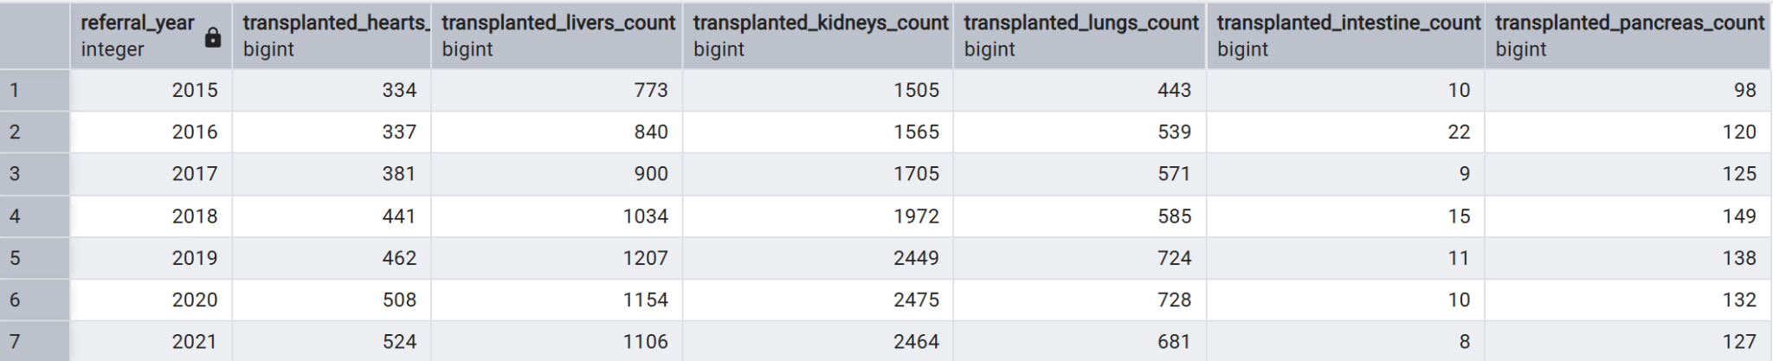

Insights:
It defines how many of each organ were transplanted each year, helps spot trends,
and shows which organs are transplanted most often, giving meaningful insights
into transplantation activity over time.

10.Top 5 causes of death per year.
Reason
To find the top causes of death based on year.

Optimization Techniques
1.Used a JOIN instead of subqueries, which is faster and more efficient
for combining tables.
2.Applied GROUP BY directly with COUNT(*), which is the most efficient way to
aggregate totals.
3.Used ORDER BY total DESC LIMIT 5, which restricts results to only the top 5 rows, reducing
output and improving performance.
4.Avoided selecting unnecessary columns by using only needed fields, which keeps the query
lightweight.

Queries
SELECT
d.cause_of_death_opo,
COUNT(*) AS total
FROM death_info d
JOIN patient p
ON d.patient_id = p.patient_id
GROUP BY d.cause_of_death_opo
ORDER BY total DESC
LIMIT 5;

Output

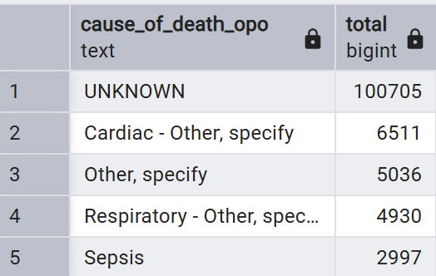
Insights:

It defines the top 5 causes of death and how common they are,
helping understand patterns in patient mortality for better planning and reporting.

11.Procurement rate (%) per OPO

Reason
To find the procurement rate in percentage based on OPO.

Optimization Techniques
1.used a JOIN instead of subqueries, which is more efficient for combining related tables.
2.Calculated the rate using SUM(CASE WHEN …) inside a single aggregation, which avoids multiple scans of the table.
3.Performed the calculation directly in SQL, preventing extra processing outside the database.
4.Grouped only by opo, keeping the grouping minimal and efficient.
5.Selected only the required columns, which keeps the query lightweight.

Query
SELECT
p.opo,
ROUND(
100.0 * SUM(CASE WHEN a.procured = 'Yes' THEN 1 ELSE 0 END)
/ COUNT(*), 2
) AS procurement_rate
FROM patient p
JOIN auth_status a
ON p.patient_id = a.patient_id
GROUP BY p.opo
ORDER BY procurement_rate DESC;
Output:

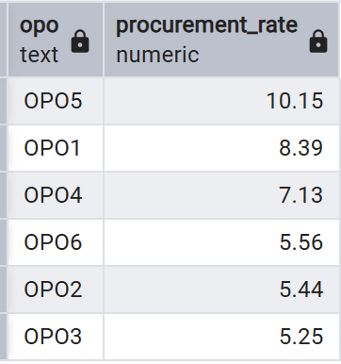
Insights:
This query gives a ranked view of organ procurement efficiency for each OPO, showing which organizations are performing best and worst in converting patient referrals into actual organ procurements.

12. Heart Transplantation Success rate.
Reason :
To find the heart success rate based on OPO.

Optimization Techniques:
1.Used INNER JOINs, which efficiently combine only matching records from the tables.
2.Performed conditional counting with SUM(CASE WHEN …), which is an efficient set-based aggregation method.
3.Calculated both numerator and denominator in the same grouped query, avoiding multiple scans or subqueries.
4.Used NULLIF(..., 0) to safely handle division by zero without extra logic, which keeps the query clean and efficient.
5.Grouped only by opo, keeping aggregation minimal and fast.

Query
SELECT
p.opo,ROUND(100.0 *SUM(CASE WHEN o.outcome_heart = 'Transplanted' THEN 1 ELSE 0 END) /NULLIF(SUM(CASE WHEN a.procured = 'Yes' THEN 1 ELSE 0 END), 0),
2) AS heart_utilization_pct
FROM patient p
JOIN auth_status a
ON p.patient_id = a.patient_id
JOIN organ_outcome o
ON p.patient_id = o.patient_id
GROUP BY p.opo
ORDER BY p.opo;

Output

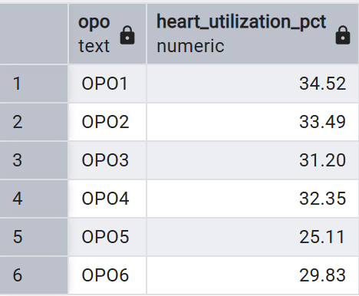
Insights:
This query provides a clear view of how effectively procured hearts are transplanted for each OPO, highlighting differences in organ utilization efficiency.

13.How many patients with brain death?
Reason : To check how many brain death patients are typically eligible for organ donation.
Optimization :
COUNT(*) is slightly more efficient
It avoids checking NULLs in patient_id
Cleaner and best practice for counting rows

Query :
select * from public.death_info where brain_death = true;
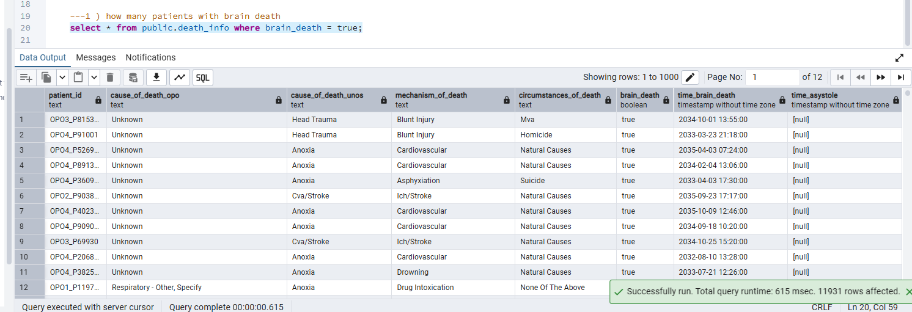
Count the total patients with brain death
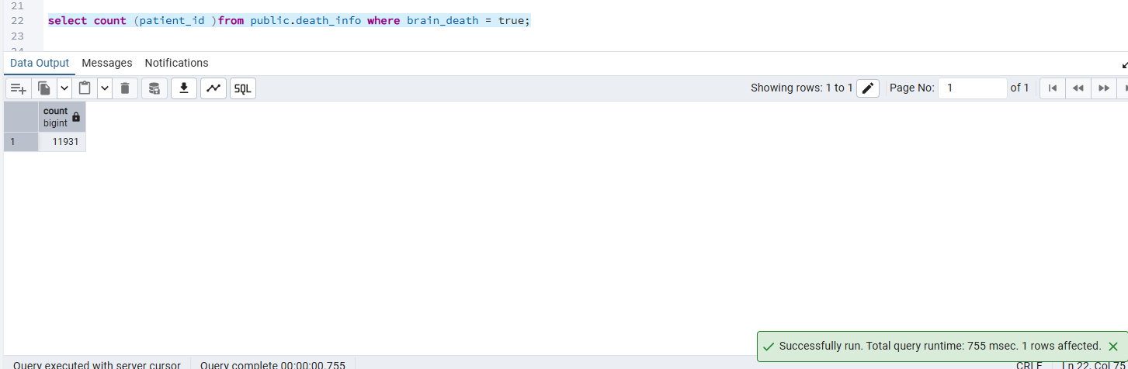
Insight : Since we only want rows where brain death happens we di count(*) counts all rows that pass the where condition which is true.

14.Write a query to list all brain death cases along with their organ outcomes and referral year.
Reason: To understand the clinical ad operational outcome of brain death cases over time which helps in measure conversion performance between compare brain death cses vs successful organ outcome.

Optimization :
- Apply WHERE d.brain_death IS TRUE early to reduce rows before joins.
- Ensure patient_id is primary key in death_info, organ_outcome, and patient for faster joins.
- Create a partial index on death_info(patient_id) where brain_death IS TRUE
- Remove duplicate column p.referral_year from SELECT to reduce unnecessary data retrieval.
Query :
select d.patient_id, d.brain_death ,p.referral_year,o.outcome_heart, o.outcome_liver,o.outcome_kidney_left,o.outcome_kidney_right,
o.outcome_lung_left, o.outcome_intestine,outcome_pancreas,p.referral_year from death_info d join organ_outcome o on o.patient_id = d.patient_id
join patient p on p.patient_id = o.patient_id where d.brain_death = true;

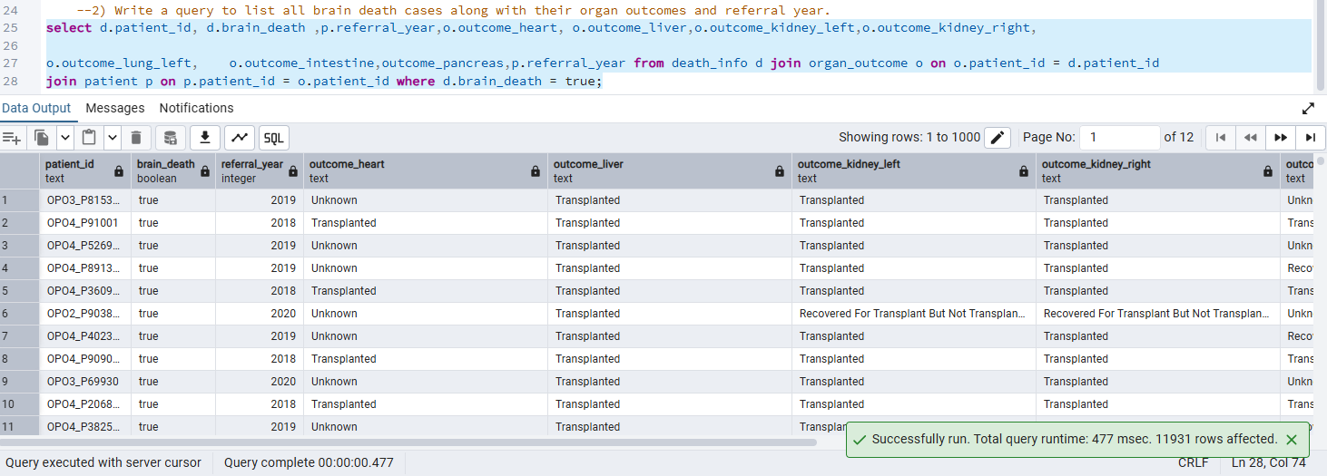

Insight: This evaluates organ utilization among confirmed brain death donors by linking donor status , referral year and organ outcome .

15.Find the total number if brain death cases per opo per year and average age.
Reason : Measure and compare OPO performance over time by quantifying brain death case volume and understanding the demographic profile (average age) of those cases for operational, clinical, and trend analysis.
Optimization :
- Used COUNT(*) instead of COUNT(d.patient_id) (faster row count).
- Used IS TRUE for proper boolean filtering.
- Filter applied before aggregation to reduce dataset.
Query :
select p.opo,p.referral_year,count(d.patient_id) as total_brain_death_cases,round( avg(p.age),1) as avg_age
from death_info d
join patient p
on p.patient_id = d.patient_id
where d.brain_death = TRUE
GROUP BY p.opo, p.referral_year order by total_brain_death_cases desc;
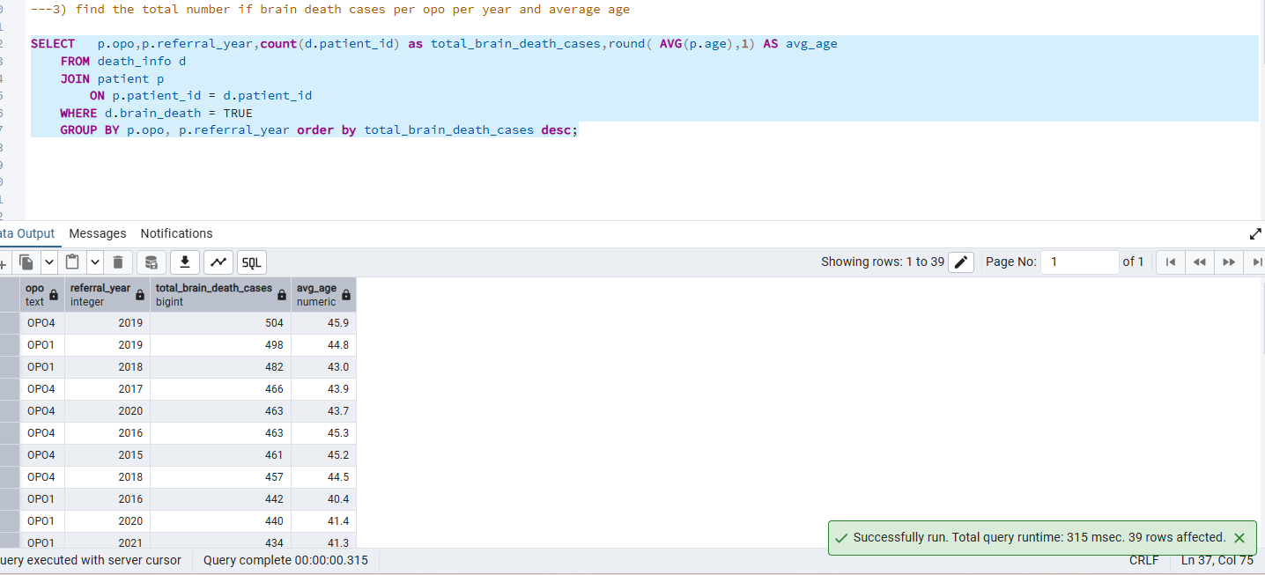

Insight : The query evaluates the which opo has more brain death case along with the year and the average age of the patient .

16.Counting how many organs were transplanted and categorize the donor category into multi - organ donor , single organ-donor and No utilization.
Reason: Evaluate organ utilization efficiency by measuring how effectively donors are converted into transplants and to classify donation patterns (multi-organ, single-organ, or no utilization) for performance analysis, process improvement, and regulatory reporting.
Optimization Technic :
- Remove the unnecessary subquery and compute organs_transplanted directly in the main query to reduce extra processing.
- Apply early filtering with WHERE d.brain_death IS TRUE to limit rows before joins.
- Ensure indexes on patient_id in all joined tables for faster joins.
- Simplify multiple CASE WHEN checks using boolean casting (::int) for cleaner and more efficient calculation.
Query :
SELECT
patient_id,
opo,
referral_year,
organs_transplanted,

CASE
WHEN organs_transplanted > 3 THEN 'Multi-Organ Donor'
WHEN organs_transplanted = 1 THEN 'Single Organ Donor'
ELSE 'No Utilization'
END AS donor_category

FROM (
SELECT
d.patient_id,
p.opo,
p.referral_year,
(
(CASE WHEN o.outcome_heart = 'Transplanted' THEN 1 ELSE 0 END) +
(CASE WHEN o.outcome_liver = 'Transplanted' THEN 1 ELSE 0 END) +
(CASE WHEN o.outcome_kidney_left = 'Transplanted' THEN 1 ELSE 0 END) +
(CASE WHEN o.outcome_kidney_right = 'Transplanted' THEN 1 ELSE 0 END) +
(CASE WHEN o.outcome_lung_left = 'Transplanted' THEN 1 ELSE 0 END) +
(CASE WHEN o.outcome_lung_right = 'Transplanted' THEN 1 ELSE 0 END) +
(CASE WHEN o.outcome_intestine = 'Transplanted' THEN 1 ELSE 0 END) +
(CASE WHEN o.outcome_pancreas = 'Transplanted' THEN 1 ELSE 0 END)
) AS organs_transplanted

FROM death_info d
JOIN organ_outcome o
ON o.patient_id = d.patient_id
JOIN patient p
ON p.patient_id = d.patient_id
WHERE d.brain_death = TRUE
) sub
ORDER BY opo, referral_year;

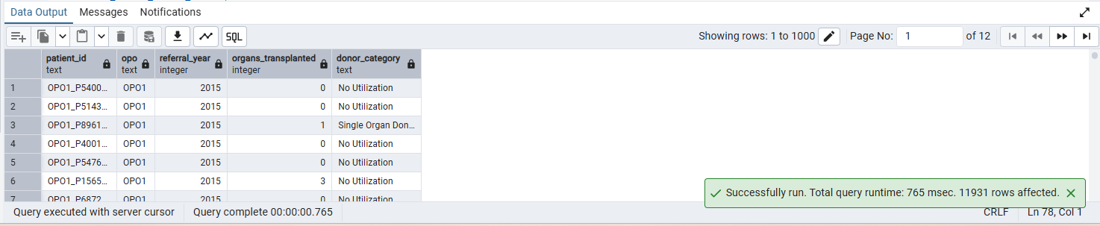
Insight: This query calculates the total number of organs transplanted per brain-death patient and categorizes each donor as a Multi-Organ Donor, Single Organ Donor, or No Utilization, enabling performance analysis by OPO and year to assess donation efficiency, organ utilization patterns, and overall donor conversion effectiveness.

17. How many referrals exist in the ORCHID dataset?
Reason:
To find out the Referral volume which is the foundation of all OPO workflow analysis.
Optimization Techniques:
Create indexes on patient.patient_id and auth_status.patient_id to speed up the JOIN.
Use COUNT(*) directly from patient if you only need total referrals (avoid unnecessary joins).
Make sure columns like authorized, procured, and transplanted are boolean for faster CASE evaluation.
Analyze and vacuum the tables regularly to keep query performance optimized.
Query:
SELECT
COUNT(p.patient_id) AS total_referrals,
SUM(CASE WHEN a.authorized = 'true' THEN 1 ELSE 0 END) AS authorized_referrals,
SUM(CASE WHEN a.authorized = 'false' THEN 1 ELSE 0 END) AS not_authorized_referrals
FROM patient p
LEFT JOIN auth_status a
ON p.patient_id = a.patient_id;
Output:
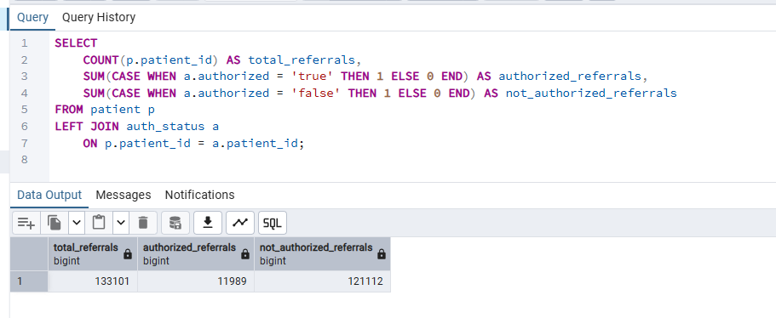
Insight:
Gives a baseline for workload and helps validate whether your import is complete.
18. List all unique organ types referred
Reason:
ORCHID includes multiple organ categories; understanding them is step one for stratified analysis.
Optimization Techniques:
1.Create indexes on organ_outcome.patient_id and patient.patient_id to speed up the JOIN operation.
2.Add an index on patient.opo to improve GROUP BY performance.
3.If frequently filtering by outcome, create an index on organ_outcome.outcome_heart.
4.Run ANALYZE regularly so the query planner chooses the most efficient execution plan.
Query:
SELECT
p.opo,
COUNT(*) AS total_patients,
SUM(CASE WHEN o.outcome_heart = 'Transplanted' THEN 1 ELSE 0 END) AS heart_tx
FROM organ_outcome o
JOIN patient p
ON o.patient_id = p.patient_id
GROUP BY p.opo
ORDER BY heart_tx DESC;
Output:
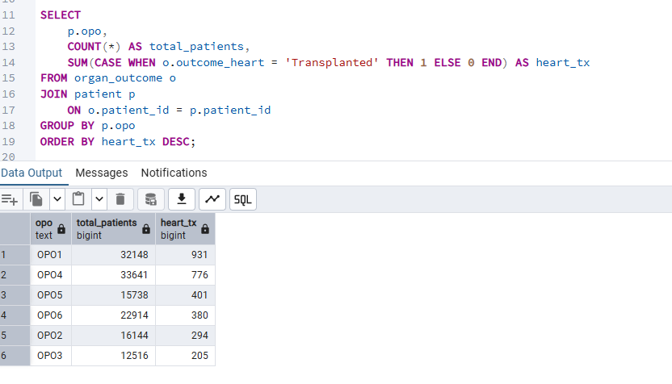
Insight:
Shows the diversity of organs in the dataset and help guide downstream modeling.

19. Count total patients
Reason:
Patient count is essential for linking referrals, outcomes, and death records.
Optimization Techniques:
Create indexes on patient.opo and patient.age to improve GROUP BY and WHERE filtering performance.
Run ANALYZE patient; regularly so PostgreSQL uses an efficient execution plan.
Query:
SELECT
UPPER(opo) AS opo_name,
COUNT(*) AS total_patients,
ROUND(AVG(age), 1) AS avg_age,
SUM(CASE WHEN gender = 'Male' THEN 1 ELSE 0 END) AS male_count,
SUM(CASE WHEN gender = 'Female' THEN 1 ELSE 0 END) AS female_count
FROM patient
WHERE age >= 18
GROUP BY UPPER(opo)
ORDER BY total_patients DESC;

Output:
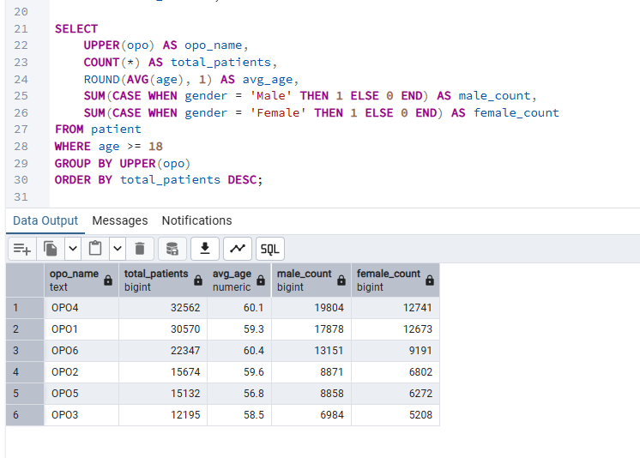
Insight:
Establishes the size of the patient population.

20.List all blood types recorded in blood_tissue
Reason:
Blood/tissue compatibility is central to organ matching.

Optimization Techniques
1.Create an index on blood_tissue.abo_blood_type and blood_tissue.abo_rh to speed up GROUP BY and conditional aggregations.
2.Run ANALYZE blood_tissue; regularly so PostgreSQL’s query planner can choose the most efficient execution plan.

Query:
SELECT
abo_blood_type,
COUNT(*) AS total_patients,
SUM(CASE WHEN abo_rh = '+' THEN 1 ELSE 0 END) AS positive_rh,
SUM(CASE WHEN abo_rh = '-' THEN 1 ELSE 0 END) AS negative_rh
FROM blood_tissue
WHERE abo_blood_type IS NOT NULL
GROUP BY abo_blood_type
ORDER BY total_patients DESC;

Output:
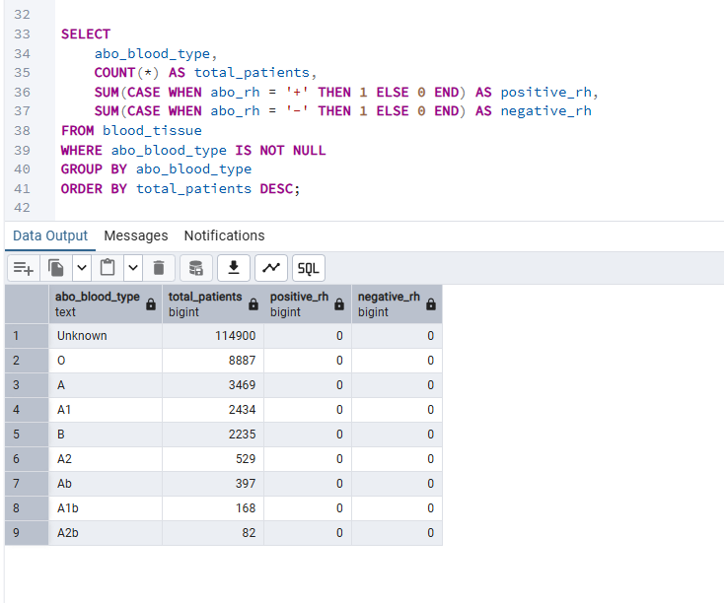
Insight:
Shows the distribution of blood types in the dataset.

